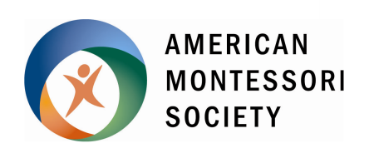
AMS Credential Services Form

Credential Upgrades

Form Updated May 2022

This form was designed to be completed in Microsoft WORD. Click on the gray box to begin typing.
CONTACT INFORMATION
Name |  |  |  | AMS Member Number | Current Member?  Yes No | Date
Street Address |  | Apt. |  | City | State/Province | ZIP/Postal Code
Country | Phone number |  | Phone type  Home Work Cell |  | Email Address

Return to AMS via e-mail to credentials@amshq.org.

AMS does not accept physical documents of any kind.

DOCUMENT(S) REQUESTED

Credential Upgrades (AMS only): $85 (must be current AMS member); includes new certificate
From Associate Credential to Full Credential (Infant & Toddler, Early Childhood only)
Must enclose official original college transcript showing degree awarded
ORIGINAL CERTIFICATE INFORMATION
COURSE LEVEL (check all that apply) | NAME OF TEACHER EDUCATION PROGRAM |  | DATE | AMS/NCME
Infant & Toddler (Birth – 3)
Early Childhood (2½ – 6)
Elementary (6 – 9, 6 – 12, or 9 – 12)
Secondary (12 – 15 or 12 – 18)
Administrator
Your name as it appeared on your original credential certificate: |  | Your name for new certificate: (Upgrades only)
Once AMS staff have had a chance to review the request you’ve submitted, you will be invoiced via our website, www.amshq.org, at which point you may complete payment. All open invoices must be paid within 4 weeks otherwise you must redo the process.
AMS does not accept checks.

